May 2015 | Bakken Crude Oil  Distributed by the NW Area Committee  www.rrt10nwac.com  Thanks to EPA Region 6 for curating the content |  | 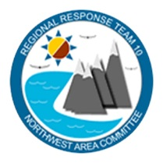
This pamphlet covers the basics of Bakken oil, including its properties and hazards, as well as preparedness and response planning activities
NW Area Committee Federal and State Spill Response Agencies
US Coast Guard, Sector Puget Sound |  | 1-206-217-6002
US Coast Guard, Sector Columbia River |  | 1-503-861-6211
US Environmental Protection Agency |  | 1-206-553-1263
Washington State Department of Ecology |  | 1-800-258-5990 (WA EMD)
Oregon Department of Environmental Quality |  | 1-800-452-0311 (OERS)
Idaho Bureau of Homeland Security |  | 1-800-632-8000 (BHS)

BAKKEN CRUDE OIL

- Introduction: What is Bakken oil?  - How is it being transported?  - Recent incidents | - Where is Bakken oil coming from?  - Bakken properties and hazards  - Planning / Response issues

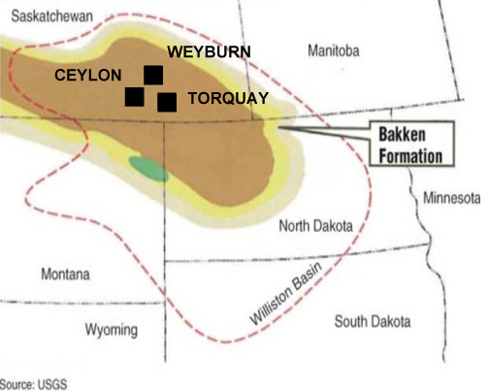
Introduction

In recent years, the large increase in the production and movement of Bakken oil have raised concerns of planning and response officials, due to the properties and hazards of these types of oils. The rapid increase in energy production from shale formations in the United States, from such regions as Colorado, Pennsylvania, South Dakota, and Texas during the past decade has greatly affected the number of rail shipments of crude oil. This fact sheet will focus on the Bakken oil and how local and State officials should appropriately address these oils if they are being transported through their areas and communities.

Bakken oil, or Bakken crude, is also known as “North Dakota Sweet,” or “North Dakota Light” crude oil, due to its low sulfur content and higher concentrations of light end hydrocarbons. In this respect, it is similar to traditional crude oil from West Texas, known as West Texas Intermediate crude. This type of crude oil is very desirable, and out of each barrel produced, approximately 95% of it is refined into gasoline, diesel fuel, or jet fuel.

Since Bakken crude, as stated above, is comparable to West Texas Intermediate, their material safety data sheets (MSDSs) or Safety Data Sheets (SDSs) are almost identical. They are both designated with Packing Group I or II under transportation regulations, and are usually placarded with the UN 1267 (Petroleum crude oil).

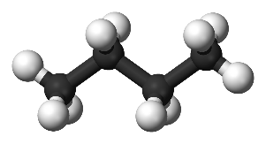
Petroleum crude oil is a light to dark colored liquid hydrocarbon containing various flammable gasses. Different crude oils may exhibit different physical and chemical properties, which can vary from one oilfield to another, or even within the same oilfield.

Light, sweet crude oils will normally contain lighter flammable gasses such as butane (C4) and propane (C3) (unless these gases have been removed). These flammable gasses can readily ignite if released, when they come in contact with an ignition source. These crude oils may also contain hydrogen sulfide, a toxic inhalation hazard material, in the vapor space of the tank car.

If you look at a typical MSDS or SDS for Bakken crude oil, you will find these constituents or ingredients listed:

Chemical Name | CAS# | Percent |  | Chemical Name | CAS# | Percent
Crude Oil (Petroleum) | 8002-05-9 | 100 by weight |  | N-Hexane | 110-54-3 | <5 by volume
Ethyl Benzene | 100-41-4 | <3 by weight |  | Xylenes | 1330-20-7 | <1 by weight
Benzene | 71-43-2 | <1 by weight |  | Hydrogen Sulfide | 7783-06-4 | <0.2 by volume
Naphthalene | 91-20-3 | 0 - 0.9 by weight |  | Total Sulfur: |  | < 0.5 wt%
Crude oil, natural gas and natural gas condensate can contain minor amounts of sulfur, nitrogen and oxygen containing organic compounds as well as trace amounts of heavy metals like mercury, arsenic, nickel, and vanadium. Composition can vary depending on the source of crude.

Where is Bakken Oil Coming From?

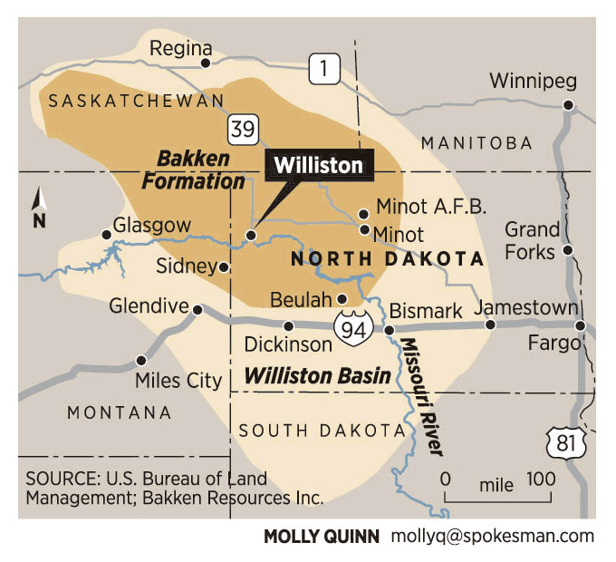
Bakken oil is being produced from fields in northwest North Dakota and northeast Montana in the United States, as well as Manitoba and Saskatchewan in Canada. The map to the right reveals the area of production.

Bakken oil is drawn from the formation through a process known as fracturing, or “fracking.”

By the way, Bakken oil is named after Henry Bakken, who owned the land in Tioga, North Dakota, where the formation was initially discovered, during drilling for oil.

In its simplest terms, fracturing stimulates the well by the use of a hydraulically pressurized liquid made of water, sand, and chemicals. The high-pressure fluid is injected into down the well to create cracks in the deep-rock formations through which natural gas, petroleum, and brine will flow back to the well more freely.
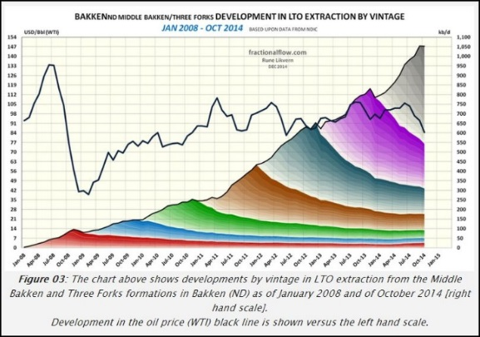
The chart to the left shows the dramatic increase in production rates in North Dakota of Bakken oil.

In January, 2009, the rate of production was approximately 100 thousand barrels per day.

As of October, 2014, that number had skyrocketed to over 1,000 thousand barrels per day.

How is Bakken oil being transported?

The massive increase in domestic production from the various regions around the country have led to challenges for oil refiners and transporters, as refineries that once received crude oil primarily from off-shore tankers have now geared up for much more by domestic transport.

According to statistics from the rail industry, the major railroads in the U.S. delivered 435,560 rail cars of crude oil in 2013, which approximates to 300 million barrels, compared to 9,500 railcars in 2008. In the first half of 2014 alone, approximately 258,541 railcars of crude oil were transported and delivered domestically.

The chart above shows that approximately 3/4 of the Bakken oil produced in the North Dakota region is transported by rail.
Bakken oil is often transported by rail via legacy DOT-111 tank cars, however, newer CPC-1232 tank cars are typically used to transport Bakken in the Pacific Northwest. The DOT-111 tank car is roughly 60 feet long, about 11 feet wide, and 16 feet high. The CPC-1232 tank car has a thicker metal shell than the DOT-111, and an enhanced, protective housing around top valves.

The DOT-111 weighs 80,000 pounds empty and 286,000 pounds when full. It can hold about 30,000 gallons or 715 barrels of oil, depending on the oil’s density.

The tank is made of steel plate, 7/16 of an inch thick. An oil tank car is typically loaded from the top valve and unloaded from the bottom valve. Loading or unloading each car may take several hours, but multiple cars in a train can be loaded or unloaded simultaneously.

Currently, in Washington, Oregon and Idaho, based on 2014 notifications of shipments by the rail carriers, Bakken oil may be transported through approximately 23 counties. Each county needs to determine if they need to plan/prepare for such shipments.

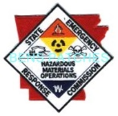
On May 7, 2014, the Secretary of Transportation issued an Emergency Restriction/Prohibition Order to all railroad carriers that transport in a single train 1,000,000 gallons (approximately 35 rail cars) or more of UN 1267, Petroleum crude oil, Class 3, produced from the Bakken shale formation in the Williston Basin (Bakken crude oil).

Rail carriers subject to the Order must provide certain information to the State Emergency Response Commission (SERC) in which the railroad carrier operates trains transporting at or above the threshold. The notification to the SERC must include:
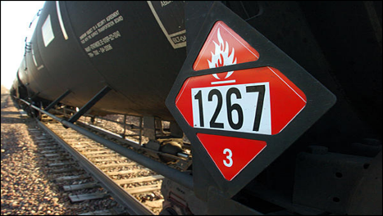
- a reasonable estimate of the number of trains implicated by this Order that are expected to travel, per week, through each county within the state;
- description of the petroleum crude oil expected to be transported;
- provision of all applicable emergency response information required by 49 CFR part 172, subpart G;
- identification of routes over which the material will be transported;
- At least one point of contact at the railroad (including name, title, phone number and address) responsible for serving as the point of contact for SERCs and relevant emergency responders related to the railroad’s transportation of Bakken crude oil.

Railroad carriers must assist the SERCs as necessary to aid in the dissemination of the information to the appropriate emergency responders in affected counties. This is a one-time report, unless circumstances change.

In addition to the above Emergency Order, on January 2, 2014, the Department of Transportation/Pipeline and Hazardous Materials Safety Administration (DOT/PHMSA) issued a Safety Alert to notify the general public, emergency responders and shippers and carriers that recent derailments and resulting fires indicate that the type of crude oil being transported from the Bakken region may be more flammable than traditional heavy crude oil.

PHMSA reinforced the requirement to properly test, characterize, classify, and where appropriate sufficiently degasify hazardous materials prior to and during transportation.

On May 1, 2015, The U.S. Transportation Secretary announced a new final rule, which was jointly developed by PHMSA and the FRA, and which requires significant rail improvements and standards for rail transportation of flammable liquids.

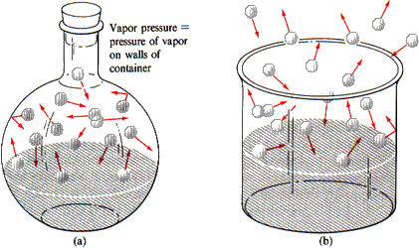
Bakken Oil Properties and Hazards

In general, Bakken crude oil presents the same physical properties as light Group II oils or other fuels. It will float on water, as its specific gravity is less than 1, and it is considered moderately volatile. This type of crude oil will contain higher concentrations of light end petroleum hydrocarbons (such as methane, ethane, propane, and butane). These dissolved gases and lighter ends will:
- Increase the vapor pressure
- Lower the flashpoint
- Lower the initial boiling point
While Bakken oil is considered a sweet crude, there may be instances where hydrogen sulfide (H2S) may be present in higher concentrations than may be expected.

Transport Information for Bakken Oil
DOT Shipping Name | Petroleum Crude Oil
DOT UN Number: | UN1267
DOT Hazard Class: | 3
DOT Packing Group: | I

The DOT Emergency Response Guidebook (2012) assigns Guide 128 to Petroleum Crude Oil (UN1267), which states:
GUIDE  128 | Flammable Liquids  (Non-Polar/Water-Immiscible) | ERG2012
POTENTIAL HAZARDS
FIRE OR EXPLOSION
- HIGHLY FLAMMABLE: Will be easily ignited by heat, sparks or flames.
- Vapors may form explosive mixtures with air.
- Vapors may travel to source of ignition and flash back.
- Most vapors are heavier than air. They will spread along ground and collect in low or confined areas (sewers, basements, tanks).
- Vapor explosion hazard indoors, outdoors or in sewers.
- Those substances designated with a (P) may polymerize explosively when heated or involved in a fire.
- Runoff to sewer may create fire or explosion hazard.
- Containers may explode when heated.
- Many liquids are lighter than water.
- Substance may be transported hot.
- For UN3166, if Lithium ion batteries are involved, also consult GUIDE 147.
- If molten aluminum is involved, refer to GUIDE 169.
HEALTH
- Inhalation or contact with material may irritate or burn skin and eyes.
- Fire may produce irritating, corrosive and/or toxic gases.
- Vapors may cause dizziness or suffocation.
- Runoff from fire control or dilution water may cause pollution.
PUBLIC SAFETY
- CALL EMERGENCY RESPONSE Telephone Number on Shipping Paper first. If Shipping Paper not available or no answer, refer to appropriate telephone number listed on the inside back cover.
- As an immediate precautionary measure, isolate spill or leak area for at least 50 meters (150 feet) in all directions.
- Keep unauthorized personnel away.
- Stay upwind.
- Keep out of low areas.
- Ventilate closed spaces before entering.
PROTECTIVE CLOTHING
- Wear positive pressure self-contained breathing apparatus (SCBA).
- Structural firefighters’ protective clothing will only provide limited protection.
EVACUATION
Large Spill
- Consider initial downwind evacuation for at least 300 meters (1000 feet).
Fire
- If tank, rail car or tank truck is involved in a fire, ISOLATE for 800 meters (1/2 mile) in all directions; also, consider initial evacuation for 800 meters (1/2 mile) in all directions.
EMERGENCY RESPONSE
FIRE
CAUTION: All these products have a very low flash point: Use of water spray when fighting fire may be inefficient.
CAUTION: For mixtures containing alcohol or polar solvent, alcohol-resistant foam may be more effective.
Small Fire
- Dry chemical, CO2, water spray or regular foam.
Large Fire
- Water spray, fog or regular foam.
- Do not use straight streams.
- Move containers from fire area if you can do it without risk.
Fire involving Tanks or Car/Trailer Loads
- Fight fire from maximum distance or use unmanned hose holders or monitor nozzles.
- Cool containers with flooding quantities of water until well after fire is out.
- Withdraw immediately in case of rising sound from venting safety devices or discoloration of tank.
- ALWAYS stay away from tanks engulfed in fire.
- For massive fire, use unmanned hose holders or monitor nozzles; if this is impossible, withdraw from area and let fire burn.
SPILL OR LEAK
- ELIMINATE all ignition sources (no smoking, flares, sparks or flames in immediate area).
- All equipment used when handling the product must be grounded.
- Do not touch or walk through spilled material.
- Stop leak if you can do it without risk.
- Prevent entry into waterways, sewers, basements or confined areas.
- A vapor suppressing foam may be used to reduce vapors.
- Absorb or cover with dry earth, sand or other non-combustible material and transfer to containers.
- Use clean non-sparking tools to collect absorbed material.
Large Spill
- Dike far ahead of liquid spill for later disposal.
- Water spray may reduce vapor; but may not prevent ignition in closed spaces.
FIRST AID
- Move victim to fresh air.
- Call 911 or emergency medical service.
- Give artificial respiration if victim is not breathing.
- Administer oxygen if breathing is difficult.
- Remove and isolate contaminated clothing and shoes.
- In case of contact with substance, immediately flush skin or eyes with running water for at least 20 minutes.
- Wash skin with soap and water.
- In case of burns, immediately cool affected skin for as long as possible with cold water. Do not remove clothing if adhering to skin.
- Keep victim warm and quiet.
- Ensure that medical personnel are aware of the material(s) involved and take precautions to protect themselves.

Characteristics Of The Five Types Of Oil Classifications
Gasoline Products  (Group I) | Diesel-like Products and Light Crude Oils  (Group II) | Medium-grade Crude Oils and Intermediate Products  (Group III) | Heavy Crude Oils and Residual Products  (Group IV) | Low API Oils - heavier than water  (Group V)
Examples – Gasoline | Examples – No. 2 fuel oil, jet fuels, kerosene, Bakken crude, West Texas Intermediate crude, Alberta crude | Examples – North Slope crude, South Louisiana crude, No. 4 fuel oil, IFO 180, lube oils | Examples – Venezuela crude, San Joaquin Valley crude, Bunker C, No. 6 fuel oil | Examples – Very heavy No. 6 fuel oil, Residual Oils, Vacuum Bottoms, Heavy slurry oils
- Very volatile and highly flammable (flash point near 100°F/40°C) | - Moderately volatile (flash point varies 100-150°F/40-65°C) | - Moderately volatile (flash point higher than 125°F/50°C) | - Slightly volatile (flash point greater than 150°F/65°C) | - Very low volatility
- High evaporation rates; narrow cut fraction with no residues | - Refined products can evaporate to no residue; crude oils do have a residue after evaporation is completed | - Up to one-third will evaporate in the first 24 hours | - Very little product loss by evaporation | - No evaporation when submerged
- Low viscosity; spread rapidly to a thin sheen | - Low to moderate viscosity; spread rapidly into thin slicks  - Specific gravity of <0.85; API gravity of 35-45 | - Moderate to high viscosity  - Specific gravity of 0.85-0.95; API gravity of 17.5-35 | - Very viscous to semisolid  - Specific gravity of 0.95-1.00; API gravity of 10-17.5 | - Very viscous to semisolid  - Specific gravity greater than 1.00; API gravity less than 10
- High acute toxicity to biota | - Moderate to high acute toxicity to biota; product-specific toxicity related to type and concentration of aromatic compounds | - Variable acute toxicity, depending on amount of light fraction present | - Low acute toxicity relative to other oil types | - Low acute toxicity relative to other oil types
- Does not emulsify | - Can form stable emulsions | - Can form stable emulsions | - Can form stable emulsions | - Can form stable emulsions
- Will penetrate substrate; non-adhesive | - Tend to penetrate substrate; fresh spills are not adhesive  - Stranded light crudes tend to smother organisms | - Variable substrate penetration and adhesion  - Stranded oil tends to smother organisms | - Little penetration of substrate likely, but can be highly adhesive  - Stranded oil tends to smother organisms | - Little penetration of substrate likely, but can be highly adhesive  - Stranded and submerged oil tends to smother organisms

Recent Incidents

While overall rail accidents have declined by 43 percent, and accidents involving the transportation of hazardous materials have been reduced by 16 percent during the last decade, incidents that do occur can potentially pose tremendous challenges for local planning and response officials, while creating significant and devastating consequences to the public, local communities, and the environment.

 | Date | Location | Description
1 | 10/19/2013 | Gainford, Alberta, Canada | 9 tank cars of propane and 4 tank cars of crude oil derailed. About 100 residents were evacuated. 3 propane cars burned, but the oil cars pushed away and did not burn.
2 | 07/05/2013 | Lac-Mégantic, Quebec, Canada | An unattended freight train transporting petroleum crude oil rolled down a descending grade and subsequently 63 cars derailed. The subsequent fires, along with other effects of the accident, resulted in the confirmed deaths of 47 individuals. In addition, extensive damage to the town center and the evacuation of approximately 2,000 people
3 | 12/30/2013 | Castleton, North Dakota | A separate derailment resulted in the derailment of 21 cars of petroleum crude oil. 18 cars ruptured, and an estimated 400,000 gallons of petroleum crude oil was released. The ruptured tank cars ignited, causing a significant fire. Approximately 1,400 people were evacuated.
4 | 11/07/2013 | Aliceville, Alabama | 26 cars derailed, resulting in 11 cars impinged by a crude oil pool fire. An undetermined amount of petroleum crude oil escaped from derailed cars and found its way into wetlands area nearby the derailment site.
5 | 04/30/2014 | Lynchburg, VA | 105 tank cars loaded with petroleum crude oil derailed. Seventeen cars derailed, and one breached. A fire ensued. 350 evacuated from immediate area. Three cars came to rest in James River, spilling up to 30,000 gallons of oil into river.
6 | 01/07/2014 | Plaster Rock, New Brunswick, Canada | 17 cars of a mixed train hauling crude oil, propane, and other goods derailed. 5 cars carrying crude oil caught fire and exploded. 45 homes were evacuated but no injuries were reported.

IT IS IMPORTANT TO REMEMBER IF AN INCIDENT OCCURS WITHIN YOUR COMMUNITY, THERE ARE STATE AND FEDERAL RESOURCES WHICH CAN BE REQUESTED TO ASSIST DURING THE RESPONSE AND AFTERMATH. BE SURE YOU KNOW THE PHONE NUMBERS AND PROCEDURES TO REACH OUT TO YOUR STATE AND FEDERAL PARTNERS IF YOU NEED HELP!

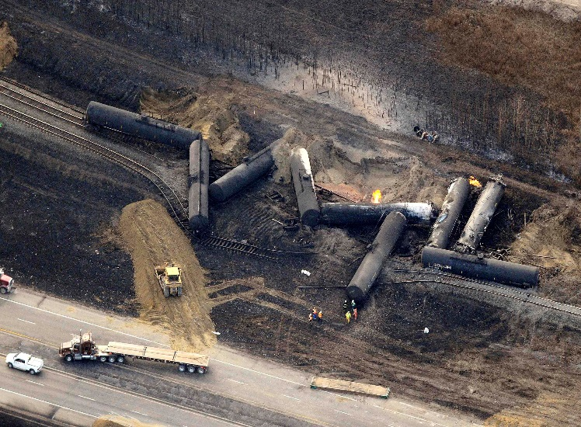 | 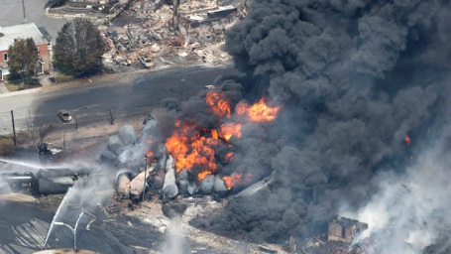
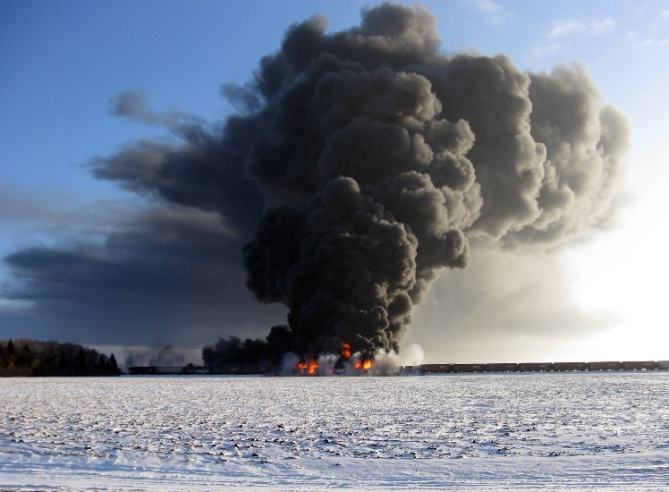 | 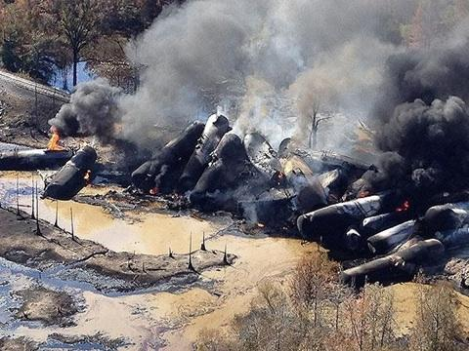
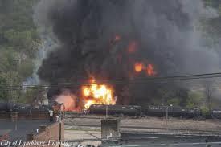 | 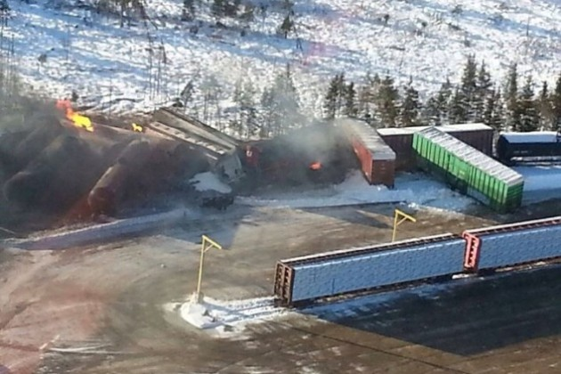

Planning / Response Issues

On May 29, 2014, DOT in conjunction with the Virginia Department of Fire Programs, a forum was convened consisting fire chiefs and emergency management officials who had experienced a crude oil or ethanol rail transportation incident within their jurisdiction.

The purpose of this forum was to share firsthand knowledge about their experiences responding to and managing these incidents and discuss things that went well and things that did not.

A summary of their experiences and lessons learned was issued by DOT/PHMSA in July, 2014, entitled, Crude Oil Rail Emergency Response Lessons Learned Roundtable Report.

The following represents key factors identified as having a direct impact on the successful outcome of managing a crude oil transportation incident:

Key Factors
- An Incident Management System (IMS) that includes a Unified Command Structure that is representative of all agencies operating at the scene must be established for all incidents (based on the National Incident Management System (NIMS) model).
- All agencies involved in emergency response operations need to understand NIMS, their specific role within NIMS, and must have a representative assigned to the Command Post to facilitate communications and coordination with all response assets.
- At a minimum, the following NIMS command staff positions must be filled:
Incident Commander  Safety Officer  Operations Section | Logistics Section  Finance Section  Planning Section | Public Information Officer  Liaison Officer
- Pre-incident planning and communication with all organizations, specifically shippers and carriers (railroads), is essential to learn about the product(s) being transported and the availability of emergency response resources.
- Emergency responders are not fully aware of the response resources available from the railroads and other organizations (e.g., air monitoring capabilities). This information would be useful in pre-incident planning, preparedness and response operations.
- Emergency response and public safety organizations need to have realistic expectations in terms of their capabilities and capacity to effectively manage an incident of this magnitude. For example, the availability of firefighting foam, foam production, equipment, appliances, water, and trained personnel need to be seriously evaluated to determine the ability to initiate and sustain such operations during an incident.
- Traditional structural firefighting strategy and tactics may not be effective in these situations. These incidents need to be approached and managed as hazardous materials incidents and this concept needs to be reinforced in emergency response plans, procedures and training programs.
- The Emergency Response Guidebook (ERG) is helpful to obtain initial response guidance for first arriving units.
- The use of proven planning and response tools and protocols such as the D.E.C.I.D.E. process and The 8 Step Process© should be integrated into emergency response plans and procedures.
The D.E.C.I.D.E. process is a framework used for decision making in hazardous materials emergencies. It consists of six steps – detect hazardous materials presence; estimating likely harm without intervention; choosing response objectives; identifying action options; doing the best option and evaluating progress.
The 8 Step Process© is a standard operational guideline used by many public safety and industrial hazardous materials emergency response teams to safely and effectively manage a hazardous materials incident. The steps are: site management and control; identifying the problem; hazard and risk evaluation; selection and use of personal protective clothing and equipment; coordination of information and resources; implementation of response objectives; decontamination; and termination of an incident.

In September, 2014, DOT PHMSA issued a guidance document, Commodity Preparedness and Incident Management Reference Sheet, concerning Petroleum Crude Oil. Included is several excerpts from this document applicable to local planning officials.

TRANSPORTATION AND PLANNING CONSIDERATIONS
- With the increased production of oil from shale reserves in states such as North Dakota and Texas, there has been a dramatic increase in the transportation of crude oil by rail. Rail shipments of crude oil from these regions are typically made using unit trains. Unit trains of crude oil are single commodity trains that generally consist of over 100 tank cars, each carrying approximately 30,000 gallons of crude oil.
- Unit trains typically move from one location (e.g., shipper’s production facility or transloading facility) to a single destination (e.g., petroleum refinery). Given the usual length of these trains (over a mile long), derailments can cause road closures, create significant detours, and require response from more than one direction to access the scene of the incident.
- In the event of an incident that may involve the release of thousands of gallons of product and ignition of tank cars of crude oil in a unit train, most emergency response organizations will not have the available resources, capabilities or trained personnel to safely and effectively extinguish a fire or contain a spill of this magnitude (e.g., sufficient firefighting foam concentrate, appliances, equipment, water supplies).
- Responses to unit train derailments of crude oil will require specialized outside resources that may not arrive at the scene for hours; therefore it is critical that responders coordinate their activities with the involved railroad and initiate requests for specialized resources as soon as possible.
- These derailments will likely require mutual aid and a more robust on-scene Incident Management System than responders may normally use. Therefore, pre-incident planning, preparedness and coordination of response strategies should be considered and made part of response plans, drills and exercises that include the shippers and rail carriers of this commodity.
- Tank cars carrying crude oil may also be found in general freight (manifest) trains that are made up of shipments of many different commodities from many different shippers. In these situations, emergency responders need to consider the potential impact that tank cars containing other hazardous commodities may have on tank cars containing crude oil if a release occurs, and vice-versa.
- To determine what specific commodities or hazardous materials may be involved, responders should obtain a train consist from the train crew or by contacting the rail carrier's emergency contact number.

HAZARD SUMMARY
- Releases may create vapor/air explosion hazards indoors, in confined spaces, outdoors, or in sewers. Remove sources of heat, sparks, flame, friction and electricity, including internal combustion engines and power tools. Use caution when approaching the scene and positioning apparatus. Implement air monitoring as soon as possible to detect the presence of combustible gasses.
- Volatile vapors released from the spill area may create flammable atmospheres. Some crude oil vapors may be heavier than air and accumulate in low areas, and travel some distance to a source of ignition and flash back.
- When working in flammable atmospheres (where any concentration of lower explosive limit (LEL) exists), extreme caution must be taken to avoid creating ignition sources. This includes but is not limited to the use of non-sparking tools and intrinsically safe/explosion- proof equipment.
- The more volatile materials in crude oil may be present in air in high concentrations creating an inhalation hazard. There is also the possibility that the crude oil may contain varying concentrations of benzene or hydrogen sulfide. Products of combustion may also include toxic constituents. Responders should wear self-contained breathing apparatus (SCBA) to avoid potential exposure.
- Use water fog spray to cool containers, control vapors, and to protect personnel and exposures. Direct the cooling water to the top of the tank. There is some potential that containers of liquid that are not properly cooled may rupture violently if exposed to fire or excessive heat. Stay away from ends of tank(s) involved in fire, but realize that shrapnel may travel in any direction.
- DO NOT APPLY WATER DIRECTLY INSIDE A TANK CAR. Apply water from the sides of the tank car and from a safe distance to keep fire exposed containers cool. Use unmanned fire monitors for cooling tank cars when available. Withdraw immediately in case of rising sound from venting pressure relief devices or discoloration of tank. If available, dry chemical extinguishing agents, such as potassium bicarbonate (i.e., Purple K) may also be used in conjunction with Class B foams.
- Improper application of fire streams may create a dangerous phenomenon known as a slopover, thereby increasing risks to emergency responders. A slopover results when a water stream is applied to the hot surface of burning oil. The water is converted into steam causing agitation of the liquid and burning oil to slop over the sides of the tank car. This can occur within 10 minutes of the product becoming involved in fire. Note: Slopover will not occur in a pool of crude oil on the ground.
- Hazardous combustion/decomposition products may be released by this material when exposed to heat or fire. These can include carbon monoxide, sulfur oxides, nitrogen oxides and aldehydes. Response personnel should exercise extreme caution on-scene and wear appropriate personal protective clothing and equipment, including respiratory protection.
- Apply Class B firefighting foam as you would on fires involving other hydrocarbons. Class B foam blankets prevent vapor production and ignition of flammable and combustible liquids. Foam is most effective on static fires that are contained in some manner. Firefighting foam is not effective on hydrocarbon fuels in motion (i.e., three dimensional fires) that include product leaking or spraying from manways, valves, fractures in the tank shell (e.g., rips, tears, etc.) or spills on sloping terrain.
- As a general rule, DO NOT flush crude oil spills with water. Most crude oils are not water soluble and will have a tendency to float on water. Some crude oils will sink and some fractions of crude oil are water soluble. For those crude oils that float on water, burning crude oil may be carried away from the immediate area and may reignite on the surface of the water.
- Prevent runoff from entering storm/sewer systems and sensitive areas, as this may create a serious hazard and potential environmental problems. Notify proper authorities, downstream sewer and water treatment operations, and other downstream users of potentially contaminated water. Runoff may be flammable and/or toxic and should be contained, treated and disposed of in accordance with applicable federal, state and local environmental regulations.

RAILROAD SAFETY PROCEDURES
Emergency response personnel should always be aware of the potential for serious injury when working in and around railcars, tracks and related equipment. The following safe operating practices should be followed when involved in emergency response operations at the scene of a crude oil train derailment:
- Expect a train or rail equipment to move on any track from either direction at any time.
- Watch for movement in both directions before crossing tracks. If the tracks are clear, walk single file at a right angle to the rails.
- Trains can approach with little or no warning. You may not be able to hear them due to atmospheric conditions, terrain, noisy work equipment, or passing trains on other tracks. Stand a minimum of 25 feet away from the tracks if possible, and face the train when rail equipment is passing through.
- Always contact the railroad to advise them of your presence – they may not know that you are on-scene or that they have a problem. Work with the railroad to be sure the track is “blue flagged” – the railroad’s version to provide protection by their lock-out, tag-out process.
- Never stand, walk or sit on railway tracks, between the rails or on the ends of ties. Never step on the rail - step over it. The rail can be a slip, trip, or fall hazard. Never put your feet on moveable parts of a rail car such as couplers, sliding sills or uncoupling levers.
- Do not occupy the area between adjacent tracks in multiple track territory when a train is passing. If crossing between two stationary railcars, ensure there is at least 50 feet between them.
- Be especially careful working in rail yards and terminal areas. Tank cars are pushed and moved, and can change tracks often. Cars that appear to be stationary or in storage can begin to move without warning. Be sure that any rail equipment is secured against movement (wheels chocked, hand brakes secured, etc.) before attempting to work on or near it. Keep at least 25 feet away from the end of a car or locomotive to protect yourself from sudden movement.
- Never move equipment across the tracks unless at an established road crossing or under the supervision of a railroad representative.
- If it is necessary to climb rail equipment, use three points of contact at all times. The ladders on rail equipment may curve around the car making it difficult to find the rung with your foot. The first step on to rail equipment is typically some distance off of the ground. When descending the ladder, step - do not jump from the last step. Normally, there is ballast around the tracks which can be uneven and shift, causing a fall hazard. Locomotive steps are considered ladders. Always face the locomotive going up and coming down.
- Never cross over or under rail equipment -- use the ladders, handholds and crossover platforms or walk around the attached equipment. Remember to block the feet and tie off ladders at the top. When laddering tank cars or box cars, always consider using two points of access - the second being a point of escape should the other become inaccessible for any reason. Plan to use your own ladders.
- Avoid the use of cell phones when within 25 feet of live tracks.
- Be aware of the location of structures or obstructions where clearances are close.
- Stay away from track switches since they can be remotely operated.

EMERGENCY PROCEDURES
Emergency response organizations should use the following framework and incident management best practices to prepare for, and safely and effectively respond to a crude oil rail transportation incident.

1. PRE-INCIDENT PLANNING AND PREPAREDNESS

- Emergency responders should determine the rail carriers of hazardous materials moving through their communities and ascertain if crude oil is one of the products being transported. This can be accomplished by contacting the individual rail carrier and requesting a list of the hazardous commodities transported through the community via the Association of American Railroads (AAR) Circular No. OT-55 protocol. This information can assist in preparing emergency response plans and procedures.
Note: A copy of the latest version of AAR Circular OT-55 and other related hazardous materials reference materials can be downloaded at http://www.boe.aar.com/boe-download.htm.
- Emergency responders should contact and engage the State Emergency Response Commission (SERC) and Local Emergency Planning Committee (LEPC) within their jurisdiction. The SERCs and LEPCs can be a valuable resource in obtaining information concerning the hazardous commodities being transported through the community, such as crude oil, as well as providing assistance with emergency planning, preparedness and response activities. LEPCs and emergency responders can seek planning information and commodity-specific training at www.TRANSCAER.com and selecting a state or region to determine the designated contacts.
- Emergency responders should also contact the railroads to identify appropriate points- of-contact and the railroad’s hazardous materials response personnel that they are likely to interface with during an emergency. This can help to establish lines of communication and access to information and resources prior to an incident. The railroads can also provide extensive rail specific emergency response training at no cost to emergency responders. Information may be obtained via the railroad’s web site or by contacting their media/public relations department.
- Emergency responders should identify the appropriate 24-hour emergency contact numbers for the major (Class I) railroads and ensure they are listed in their emergency operations and response plans. The emergency contact numbers for the Class I railroads are listed below.
Company Emergency Number Company Emergency Number
BNSF Railway (800) 832-5452 Kansas City Southern Rail Network (877) 527-9464
Canadian National (CN) Railway (800) 465-9239 Norfolk Southern Railroad (800) 453-2530
Canadian Pacific (CP) Railway (800) 716-9132 Union Pacific Railroad (888) 877-7267
CSX Transportation (800) 232-0144
Note: Emergency responders should also contact any Short Line or Regional Railroads that service their areas to obtain emergency contact information. These organizations should also be part of any pre-incident planning, preparedness and training/exercise activities.
- Emergency responders should establish contact with their state and local environmental protection agency representative(s) to identify potential air monitoring and spill control resource capabilities. These resources should be included in the organization’s emergency response plan.
- Emergency responders should contact federal agencies such as the U.S. Coast Guard to determine the level of assistance that may be provided in the event of a spill in navigable waterways located in their jurisdiction. This resource, as well as other federal resources, can be contacted through the National Response Center (NRC) at 1-800-424-8802.
- Organizations should include a railroad annex in their emergency response plan that specifically addresses crude oil rail transportation emergency response operations. This annex should include:
  - hazard analysis that identifies the potential risks to people and property
  - emergency contact lists
  - resource listings
  - equipment inventories
  - foam and water supply requirements for operations at remote sites
  - incident management system roles and responsibilities
  - mutual aid response assets
  - law enforcement scene security and control operations
  - support and recovery assets
Note: Emergency response plans and procedures should be developed in close coordination with the railroad since they will play a critical role in response and recovery operations. Tests and drills should be conducted to exercise the plan at regular intervals to identify any issues that might require corrective action prior to an actual incident.

2. INCIDENT MANAGEMENT PRINCIPLES

- Initial site management and control will be a critical benchmark in managing the problem.
- Isolate and secure the area. Establish a secure perimeter and entry control points to prevent unauthorized personnel from entering the scene. This can be accomplished with tape, barricades, traffic cones, or assigned fire service or law enforcement personnel.
- The location of the restricted area should be communicated to all impacted personnel operating on the scene. Begin a site assessment from a safe distance, upwind and uphill. An Incident Command Post (ICP) should be established outside the impacted area as soon as possible.
- Follow initial guidance provided by the Emergency Response Guidebook (ERG) if practical. Establish a Staging Area in the cold zone for responding equipment and personnel.
- The National Incident Management System (NIMS) should be the framework used to manage all incident operations. Information on NIMS can be obtained at http://www.fema.gov/national-incident-management-system. Unified Command should be established that integrates those agencies and organizations with legal or jurisdictional responsibility. Liaisons should be provided at the ICP by assisting or cooperating agencies to ensure effective communication and coordination of resources.
- Due to the size, duration and complexity of these incidents, Incident Commanders should consider the possibility of additional support from regional or state All-Hazard Incident Management Teams (AHIMTs).
Note: AHIMTs are a multi-agency/multi-jurisdictional team for extended incidents formed and managed at the local, state or tribal level. It is a designated team of trained personnel from different departments, organizations, agencies and jurisdictions. AHIMTs are deployed as a team representing multiple disciplines who manage major and/or complex incidents requiring a significant number of local, state or tribal resources. They do not assume command of the incident; they help local officials manage incidents that extend into multiple operational periods and require a written Incident Action Plan (IAP). These incidents can include weather-related disasters such as a tornado, earthquake, or flood or major hazardous materials incidents such as train derailments.
- Emergency responders should anticipate a large number of liaison agencies operating at the scene (e.g., U.S. Coast Guard, Environmental Protection Agency, National Transportation Safety Board, Chemical Safety Board, private contractors). In addition, non-emergency regional and municipal agencies may have a role to play and need to be integrated into the command structure.
- The railroad will integrate its response assets into the public safety NIMS structure. While the exact structure will vary based on the scope and nature of the incident scenario, it will often be integrated as the Railroad Branch within the Operations Section.
- Large-scale incidents may require activation of the jurisdiction’s Emergency Operations Center (EOC). The EOC should be fully staffed and the roles and responsibilities of all participating agencies must be clearly defined in the organization’s emergency response plan.

3. PROBLEM IDENTIFICATION

- Identify, confirm, and verify the presence of the hazardous material(s) and the extent of the problem. This can be done through shipping papers (i.e., train consist), placards, labels, container shapes, markings/colors and senses (e.g., observable plume).
- Identify the rail carrier and locate the train crew. The conductor will have the complete train consist immediately available on the scene. Maintain contact with the conductor and crew until they are relieved by a railroad official(s).
- Notify the rail carrier’s emergency operations center to have rail traffic stopped to avoid entering the location of the incident to avoid further risk to personnel operating at the scene. Request that a copy of the train consist or wheel report be sent to the ICP.
- Responding railroad officials may also have copies of the train consist. In the absence of shipping papers, emergency responders should use binoculars from a safe distance upwind, and try to locate any 4-digit identification numbers on the placards (or orange panels) displayed on the rail cars. If shipping papers, placards, markings, or labels are destroyed, the reporting marks and number on the railcar can be used to identify the commodities present.
- When contacting the railroad, provide the following information:
  - Your name, location, organization name and telephone number
  - Location of incident (provide the railroad with the DOT Crossing Number or the railroad milepost so the specific location can be identified)
  - Type and number of containers involved
  - Presence of markings, labels, reporting marks or placards on tank car
  - Presence of smoke, fire or spill
  - Extent of damage
  - Topography
  - Weather conditions
  - If pictures can be taken from a safe position, do so and send to a railroad representative as quickly as possible
- Be aware of utilities that commonly run next to or in the railroad right-of-way. As part of your scene size up, look for downed signal and communication lines, power lines, buried utilities and above ground switch heating systems.

4. HAZARD ASSESSMENT AND RISK EVALUATION

- The hazard assessment and risk evaluation process is a critical step to identify the level of danger posed by an incident involving the product(s), containers and their behavior, which is generally related to their physical and chemical properties.
- Risks refer to the probability of suffering harm or loss and are different at each incident and need to be evaluated by the Incident Commander.
- Emergency responders can use a number of reference materials such as the ERG, Safety Data Sheets (SDSs), technical specialists available by contacting the shipper or railroad, or contacting the Chemical Transportation Emergency Center (CHEMTREC) at 1-800-424-9300, or the 24-hour emergency contact telephone number required to be included on the shipping papers by the federal hazardous materials regulations.
- Evaluate the risks of personnel intervening directly in the incident. Consider the limitations of the people involved and the ability to have adequate resources available on site (e.g., sufficient firefighting foam concentrate, water supplies, appliances, equipment, trained personnel and technical expertise) and the ability to sustain operations for extended periods of time (hours or days).
- The level of risk will be influenced by the following factors:
  - Hazardous nature of the material(s) involved
  - Quantity of the material(s) involved
  - Type(s) of stress applied to the container and breach / release scenarios
  - Proximity of exposures and nature of terrain
  - Level of available resources (e.g., adequate foam supply, location of foam supply, response time and appliances/equipment)
- Response personnel need to consider the following factors that may influence the behavior of a hazardous material:
  - Inherent properties and quantity of the material
  - Design characteristics of the container
  - Environmental factors (e.g., weather, topography, surrounding physical structures)
- The following factors should be considered to help estimate the potential impact of the problem:
  - Has the container been breached? If so, is product flowing?
  - Where will the container and its contents go if released?
  - Why are the container and its contents likely to go there?
  - How will the container and its contents get there?
  - When will the container and its contents get there?
  - What harm will the container and its contents cause when they get there?
  - How much material has been released? What is the proximity to people, property and the environment?
  - Is the material on fire? Are other tank cars at risk of becoming involved?
  - Do you have the capability of successfully controlling fire spread, which in some cases may require a minimum of approximately 500 gallons per minute per exposed tank car?
  - Are adequate foam supplies and equipment available for post-fire operations that may last for several hours or days?
- For non-fire spill scenarios:
  - Have the concentrations of any flammable or toxic vapors present been determined using air monitoring instruments? What are the flammability and toxicity readings?
  - Has the need for continuous air monitoring been evaluated and discussed with technical specialists?
  - Can sources of ignition be removed and/or eliminated?
  - Are adequate foam supplies and equipment available for vapor suppression?
Note: Agencies should refer to the most recent edition of NFPA 11 - Standard for Low- Medium-and High-Expansion Foam for information concerning the specific requirements for foam application.
- Based on the results of the hazard assessment and risk evaluation process, are there adequate resources available to respond to the scene within a reasonable timeframe so that intervention efforts will be successful?
Note: An initial benchmark to assess your agency’s capability to successfully manage an incident involving a unit train carrying crude oil is your operational capability to respond to and successfully manage a gasoline tank truck incident (which typically involves approximately 9,000 gallons of gasoline). With regard to quantity of product, one tank car of crude oil is equivalent to approximately three gasoline tank trucks. The potential magnitude of this type of incident must be considered when preparing emergency plans and operational procedures.
- Emergency responders should use the information and options selected as the foundation to develop an IAP for the incident. An IAP should be developed for any incident that has the potential to last at least 24 hours, and a new/updated IAP developed for each successive operational period.
- If your agency is not fully prepared and capable in terms of resources, equipment and properly trained personnel to intervene, defensive or non-intervention strategies will likely be the preferred strategic option.

5. SELECT PROPER PERSONAL PROTECTIVE CLOTHING AND EQUIPMENT

- Assure that emergency responders are using the proper personal protective equipment (PPE) and clothing equal to the hazards present. Structural firefighting protective clothing (SFPC) and positive-pressure SCBA should be the initial level of PPE selected.
- Rescue should be performed from an uphill and upwind location, if possible.
- Any changes in the level of PPE should be based on the results of air monitoring operations. Continuous monitoring with a combustible gas indicator and instruments capable of detecting toxic components of crude oil vapors (e.g., hydrogen sulfide, etc.) are important in ensuring site safety. These instruments can include detector tubes or photoionization detectors (PIDs).
CAUTION: SFPC will provide thermal protection for fires involving crude oil; however SFPC is porous and will absorb liquids. For scenarios that do not and will not include the possibility of fire, such as spill control and clean-up activities, including decontamination, chemical liquid splash protective clothing protection and a compatible NIOSH-approved respirator may be required depending on the properties of the product.
- Information and guidance on the selection of personal protective equipment for oil spill response is available in American Petroleum Institute (API) Recommended Practice (RP) 78 – Personal Protective Equipment Selection for Oil Spill Responders. Copies of the RP can be obtained by contacting API at (202) 682-8000 or on-line at www.api.org (Product No. G09801).

6. LOGISTICS AND RESOURCE MANAGEMENT

- Order specialized equipment and technical resources early in the incident. If you are unsure of your initial resource requirements, always call for the highest level of assistance available. Do not wait to call for additional resources or activate mutual aid agreements.
- Establishing a Logistics Section early in the incident will be critical in providing the necessary support, resources and services to meet operational objectives. The size, scope and resources needed to successfully manage a crude oil rail transportation incident will overwhelm the capability of most emergency response agencies.
- Emergency planning and response agencies must identify their logistical needs, identify agencies or organizations that can meet those requirements, and effectively manage the resources available from those identified sources within the NIMS framework.
- The railroads will be the primary providers of logistical support and resources. Rail carriers can provide emergency response resources, air monitoring and environmental management capabilities, technical specialists and contractors to safely manage the consequences of a crude oil train derailment. For example, rail carriers may use the services of private contractors to provide air monitoring and toxicology assessments.
- The time required for assets to arrive on scene and initiate operations must be taken into account since long delays can diminish operational effectiveness. Logistics for access, positioning and movement should be considered, including the need for escorts to facilitate prompt access to the scene.
- Technical specialists and contractor support can also be made available from the shipper and can be obtained by contacting the 24-hour emergency telephone number provided on shipping papers or by contacting CHEMTREC at 1-800-424-9300.
- Emergency responders may also obtain assistance from the NRC by calling 1-800-424-8802. For example, the NRC can provide 24-hour access to federal government agency resources and technical assistance. The NRC also serves as the EPA’s Hazardous Materials Hotline and the USCG Oil Spill Hotline.

7. SELECT AND IMPLEMENT RESPONSE OBJECTIVES

- The initial stage of an incident involving crude oil should include an analysis of appropriate site specific response procedures and potential effects that an incident would have on nearby life, property, critical systems and the environment.
- The ERG should be used by all emergency responders to obtain initial response guidance for crude oil incidents.
- Traditional firefighting strategies and tactics may not be effective in these situations. These incidents also need to be approached and managed as a hazardous materials problem to ensure that proper and appropriate technical assistance and the support of outside resources are notified and requested as soon as possible.
- Use the railroad’s emergency telephone number to establish communication with the railroad and stay in constant communication with the railroad. If the train crew is disabled or unavailable, the train consist is available from the Railroad Emergency Telephone Number point-of-contact and can be sent to the scene via e-mail or fax.
- Confirm your location with the Railroad Emergency Telephone Number point-of-contact by observing mile posts or the individual grade crossing identification numbers at or near the scene.
- Coordinate operations with the railroad, chemical shippers and manufacturers, CHEMTREC and/or the shipper’s 24-hour emergency contact to ensure that you have access to all the information available concerning the commodity and tank car(s) involved in the accident.
- Utilize the railroads’ hazardous materials personnel when they arrive on scene. They can assist with size-up and damage assessment. These personnel have been specifically trained to respond to railroad emergencies and derailments.
- Based on the collection, evaluation and verification of response information, emergency responders need to determine whether the incident should be handled offensively, defensively or by non-intervention. Remember that offensive tactics significantly increase the risks to emergency responders.
- The following factors should be considered as part of developing the initial response strategy:

 | QUESTION | RESPONSE CONSIDERATIONS
 | Are there any life safety exposures in danger that responders must address right now? Can responders safely evacuate or protect in place? | Number of people to be protected, ability of public to move, available time, resources needed, adequate facilities to shelter evacuees.
 | Can responders safely approach the incident? | Location of the incident, access and terrain, number of tank car(s), extent of damage, size of spill, leak or fire involved.
 | Do responders fully understand the nature and scope of the problem? | Hazard assessment and risk evaluation must be completed and the results shared with technical specialists from the railroad and/or shipper.
 | If a fire is involved, do responders have immediate access to sufficient foam and water supplies that are required for effective fire control/suppression operations?  If a spill is involved, do responders have the necessary spill control equipment readily available on-site?  Can fire suppression agents be effectively applied to the tank car(s) involved? Can cooling water be effectively applied to any exposures impacted by direct flame impingement?  If not on fire, can potential ignition sources be removed and/or eliminated? | Most fire departments will not have adequate foam, water or spill control resources for an initial attack on a crude oil derailment scenario with large fires. Defensive operations will likely be required until sufficient foam concentrate, water, spill control and related support resources are on-scene.  Do responders have spill control and vapor suppression equipment/chemical available on- site?  Fire suppression agents and cooling water must be able to reach their intended targets to be effective. If access, supply or equipment is limited, the ability of suppression agents and cooling water to reach the affected area(s) will be diminished.  Vehicle traffic may need to be curtailed. Automatic switching systems (i.e. industrial air conditioning units, traffic signals) need to be switched off, etc.
 | Will extinguishment improve or worsen the incident and what is the environmental impact of doing so? | In some situations, the best and safest option may be defensive or non-intervention tactics which allow the fires to burn out. Attempting to extinguish the fire(s) may cause additional risk to personnel and damage to the environment. The decision to protect exposures and let the product burn must be considered.
 | Have appropriate notifications been made or has the organization’s emergency response plan been activated? | These incidents cannot be safely and effectively managed alone. Additional technical support and resources must be requested immediately in accordance with the agency’s emergency response plan. The railroads and shippers will be the primary means of technical support and resources and are an integral component of the organization’s emergency response plans, procedures and operations.
8. CLEAN-UP AND POST-EMERGENCY OPERATIONS

- Establish a decontamination corridor in the warm zone away from the contaminated area. Ensure that all protective clothing and equipment is isolated for proper disposal and/or cleaning.
- Ensure proper decontamination of emergency personnel before they leave the scene. Crude oil vapors can saturate protective clothing and be carried off-site. Personnel should monitor for hazardous vapors before removing PPE.
- Use a massive water rinse on the outer shell of protective clothing. Maintain appropriate respiratory protection throughout the decontamination process.
- Contain all runoff since it may contain harmful contaminants. Properly dispose of in accordance with applicable federal, state and local environmental regulations.
- Conduct a post-incident analysis to properly document the incident and identify follow-up activities.

SAFETY ON SCENE
Bakken Crude Oil – Rail Response Considerations – January, 2014
International Association of Fire Chiefs (IAFC)
The Pipeline and Hazardous Materials Safety Administration (PHMSA) has issued a safety alert to notify emergency responders that recent derailments and resulting fires indicate that the crude oil originating in the Bakken region may be more flammable than crude oil from other regions.

The IAFC Hazmat Committee and Industrial Section have prepared this briefing for IAFC members and other first responders.

The Issues and Response

- Current capacity of existing pipelines has been unable to keep up with the growing crude oil supply forcing more crude shipments by rail.
- There have been a number of major derailments involving tank cars containing crude oil in the past year.
- Bakken Crude is very light crude. Its flashpoint and boiling points may be lower than other traditional light crude oil.
- First responders should check with local rail carriers, storage, and refining facilities in their response areas to see if this type of crude oil is moving through or into their area.
- If shipments of flammable liquids are moving through your response area, first responders should pre-plan for the possibility of an emergency incident, which may include:
  - Rail events involving the derailment of tank cars.
  - Highway events involving the rollover of cargo tank trucks.
  - Fixed facility events involving a release from storage tanks or pipelines.
- “PHMSA stresses the importance of appropriate classification and packing group (PG) assignment of crude oil shipments, whether the shipment is in a cargo tank, rail tank car or other mode of transportation. Emergency responders should remember that light sweet crude oil, such as that coming from the Bakken region, is typically assigned a packing group I or II. The PGs mean that the material's flashpoint is below 73 degrees Fahrenheit and, for packing group I materials, the boiling point is below 95 degrees Fahrenheit. This means the materials pose significant fire risk if released from the package in an accident."
- If Bakken crude is involved in an incident, use caution in reviewing the shipping documents (shipping papers, consists, etc.) due to the possible that the flash points and/or boiling points may be classified incorrectly – lower temperatures points may be more appropriate.
- Tank cars of crude oil that are on fire and cars adjacent to other cars that are on fire should be cooled at the vapor space with unmanned hoselines to prevent heat induced tears.
- When operating near a crude oil fire or spill emergency scene first responders should wear the appropriate PPE and respiratory protection. All crude oils contain a percentage of benzene which is a known carcinogen and a percentage of hydrogen sulfide which is a toxic and flammable gas.
- Crude oil is lighter than water and will float on the surface. Spills near waterways may spread rapidly especially in moving water situations. Containment booms may need to be deployed quickly.
- Weather conditions can affect the response to crude oil emergencies. Warmer temperatures can cause crude to vaporize quickly and migrate creating additional concerns.

Responder Preparedness

Pre-incident planning of crude oil movement will provide a mechanism for making effective and informed decisions in advance of an emergency. It allows responders to gather valuable information prior to an emergency. Periodic review will provide timely and accurate information that can be useful during a hazardous materials emergency. Pre-planning provides a tool for response agencies to begin the collaborative process of emergency planning.

Responders should develop comprehensive hazardous materials pre-plans for transportation emergencies involving both rail and over the road as well as the potential impact on towns, communities, and facilities where those products are moved or handled. Important preparedness elements include:

- Emergency contacts and notifications  - Location/exposures  - Emergency response resources  - Type of construction  - Type of business/process  - Water supply  - Facility access  - Communications and security  - Electrical/gas shutoffs  - Water shutoffs and sprinklers  - Location/type/quantity of chemicals and their hazards  - Emergency medical support availability | - Work schedules/number of employees on site  - Emergency resources on site  - Contingency plans for fixed facilities  - Protective clothing available on site  - Vulnerability of surrounding area/ability to evacuate  - Adjacent facilities and other exposures that cannot be evacuated or shut down  - Compatibility of resources  - Waterways and storm sewers, particularly those that empty into a waterway  - Public information and notification plans

In the past, traditional heavy crude emergency incidents were considered a low probability – high consequence for rail and over the road events since the majority of crude was transported through the pipeline system.

Now that production has increased, especially light sweet crude from the Bakken region, more crude oil is being transported by rail and cargo tank truck. Hence, crude oil emergency incidents have now become a higher probability-high consequence event.

First responders must remain vigilant of the type and amount of crude oil passing through their response area. An understanding of the chemical properties of this type of light sweet crude oil is paramount.

PHMSA and the FRA have stressed to the providers of crude oil to make sure that the information provided on their shipping documents and the placarding of cars is appropriate for the characteristics of the product. PHMSA will be conducting tests on the chemical properties of this type of crude oil to assist in determining the suitable shipping information.

Sources of information for this report includes:
Commodity Preparedness and Incident Management Reference Sheet; Department of Transportation / Pipeline and Hazardous Materials Safety Administration; September, 2014; http://phmsa.dot.gov/pv_obj_cache/pv_obj_id_D49E5CEF1AC2AB4A887FDA7364FDD00E87BE0200/filename/Petroleum_Crude_Oil_CERG.pdf

Crude Oil Rail Emergency Response, Lessons Learned Roundtable Report; Department of Transportation / Pipeline and Hazardous Materials Safety Administration; July 1, 2014; http://www.phmsa.dot.gov/pv_obj_cache/pv_obj_id_0903D018579BF84E6914C0BB932607F5B3F50300/filename/Lessons_Learned_Roundtable_Report_FINAL_070114.pdf

“Bakken Crude Oil Presentation: Emerging Risks”; National Response Team Training Subcommittee; January 12, 2015

Safety On-Scene; International Association of Fire Chiefs, Fairfax, Virginia; www.iafc.org; January, 2014;
http://www.phmsa.dot.gov/pv_obj_cache/pv_obj_id_3BF72340F1B897D8BA9D72359D2019808AE20100/filename/safetyOnScene_haz_crudeOilBakken.pdf

U.S. Rail Transportation of Crude Oil: Background and Issues for Congress; Congressional Research Service, Washington, DC; www.crs.gov; February 21, 2014; https://www.fas.org/sgp/crs/misc/R43390.pdf

Amended and Restated Emergency Restriction/prohibition Order; U.S. Department of Transportation, Washington DC; March 6, 2014; http://www.phmsa.dot.gov/pv_obj_cache/pv_obj_id_D03C7A1E859361738D791378144472BF368F0200/filename/Amended_Emergency_Order_030614.pdf

Bakken Shale Fact Sheet; Institute for Energy Research, Wasington, DC; http://instituteforenergyresearch.org/; August, 2012; http://instituteforenergyresearch.org/wp-content/uploads/2012/08/Bakken-Fact-Sheet.pdf

Preliminary Guidance from Operation Classification – Safety Alert; U.S. Department of Transportation; January, 2014; http://www.phmsa.dot.gov/pv_obj_cache/pv_obj_id_111F295A99DD05D9B698AE8968F7C1742DC70000/filename/1_2_14%20Rail_Safety_Alert.pdf

- The articles herein are provided for general purposes only.
- EPA does not accept responsibility for any errors or omissions or results of any actions based upon this information.
- Please consult the applicable regulations when determining compliance.
- Mention of trade names, products, or services does not convey, and should not be interpreted as conveying official EPA approval, endorsement, or recommendation.

