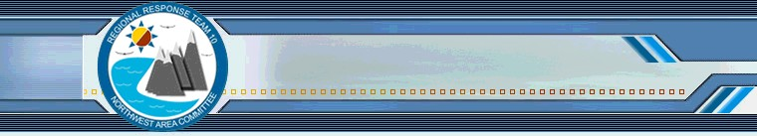
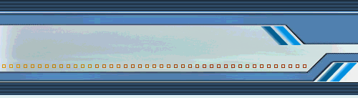
NWACP 6th Annual Summit

6th Annual Northwest Area Contingency Plan Summit
December 1, 2016

Contents
• Date, Time and Location
• Purpose
• Who Should Attend
• Agenda
• How to Participate
• Advance Reading

Date, Time and Location
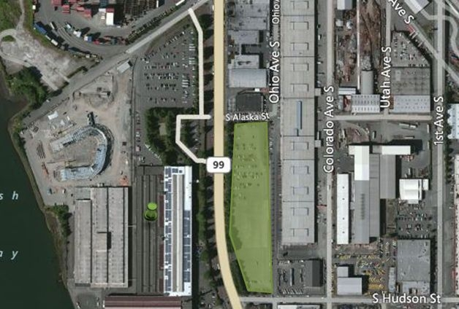
Safe Crosswalk
Federal Center South, Galaxy Room
4735 East Marginal Way S, Seattle, WA 98134

December 1, 2016,
8:30 – 4:30 PM

Parking Area
Federal Center South

Purpose
The 2016 Northwest Area Contingency Plan 6th Annual Summit will provide an opportunity for broader input on the updates to the next Northwest Area Contingency Plan (NWACP), which will be published in January 2018. This summit will provide the executive committee of the Northwest Area Committee a prioritized list of plan updates and potential task forces to develop the updates. The executive committee will decide which plan updates will be included in the 2018 NWACP based on the input provided at the annual summit.

For more information on the NW Area Contingency Plan and its role in WA, OR and ID, please see our general brochure or visit our website: www.rrt10nwac.com.

Who Should Attend
Oil and HazMat Spill response organizations, industry, government, non-profit other interested parties or individuals.

Agenda

Time | Description
8:30 – 9:00 | Introduction, Summit Goals & Objectives, Review of outcomes from 2015 Summit and the 2016 Task Forces
9:00 – 11:00 | Issues Discussion
11:00 – 11:15 | Break
11:15 – 12: 00 | Small Group Breakout
12:00 – 12:45 | Lunch
12:45 – 2: 15 | Breakout Briefings
2:15 – 2:30 | Nominal Process & BREAK
2:30 – 3:00 | Voting Results & Priority Consensus
3:00 – 3:30 | Task Force Volunteers
3:30 – 4:30 | Exercise Discussion

How to Participate

Each organization participating will get 3 minutes and 1 Power Point slide to present the issues that they would like addressed in the 2018 NWACP. These issues may include:

• Plan updates or additions
• Issues that need to be addressed through policy updates that may or may not result in a plan update
• Policies or plans that need to be exercised

If you do not have anything that you would like to present, then just RSVP. You will still be able to help shape the 2018 plan update by identifying work products to be completed by task forces or volunteering for task forces. Please be sure to complete the advanced reading listed below so that you can fully participate in the discussions.

If you would like to present potential 2018 updates then you must follow the instructions on the presentation slide template and email your slide to clark.josie@epa.gov by close of business on November 10, 2016.

Read Aheads
Please review the following documents to help prepare for the discussions that we will have during the summit:

• Introduction to the Northwest Area Contingency Plan
• Presentation Slide Template (if presenting proposed 2017 updates or issues)
• Draft 2017 NW Area Contingency Plan (pls see Preface Section for a listing of all changed content)

