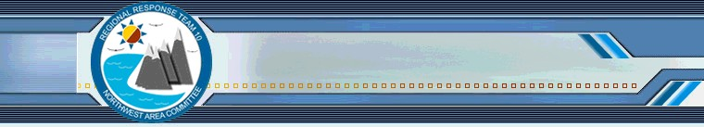
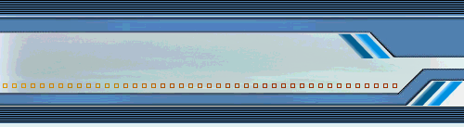
NWACP Annual Summit

November 28, 2018
8:30 AM to 4:30 PM

Federal Center South
4735 East Marginal Way S
Seattle, WA 98134

Purpose
The purpose of the Annual Northwest Area Contingency Plan (NWACP) Summit is to provide an opportunity for input on the 2020 Northwest Area Contingency Plan (NWACP) and help set priorities for the NW Area Committee, the RRT, and the response planning community in 2019. The summit is a forum for the entire NW response community to interact and help develop response planning priorities for the coming year. These priorities will drive the development of the NWAC Task Forces, which annually provide updates to the NWACP. The NW response community is invited to participate in the Task Forces.

Who Should Attend
Oil and HazMat Spill response organizations, industry, government, non-profits, and other interested parties or individuals.

Draft Agenda

Time | Description
8:30 – 9:30 | Introductions, Summit Goals & Objectives, Review of outcomes from 2017 Summit and the 2018 Task Forces
9:30 – 10:30 | Issues Presentations from response community
10:30 – 10:45 | Break
10:45 – 12:15 | Small Group Breakout sessions to discuss issues
12:15 – 13:15 | Lunch
13:15 – 14:45 | Small Group Breakout Briefings to the entire audience
14:45 – 15:00 | Voting Process and BREAK
15:00 – 15:30 | Voting Results and preliminary recommendations for Task Forces
15:30 – 16:00 | Recruiting Task Force Volunteers
16:00 – 16:30 | Event wrap-up and next steps

How to Participate
Each organization participating will get 3 minutes and 1 Power Point slide to present the issues that they would like addressed in 2019, these may include:

• Plan updates or additions for the 2020 NWACP
• Issues that need to be addressed through policy updates that may or may not result in a plan update
• Policies or plans that need to be exercised

There will be up to two minutes for questions for each presenter.

If you would like to present issues please follow the instructions and template attached and email your slides by October 24th to the following:

Elizabeth.j.petras@uscg.mil
muller.lori@epa.gov
elisa.j.lynne@uscg.mil

Deadline for issues slides is October 24th, 2018.

Background Documents/Recommended Reading
Please review the following documents to help prepare for the discussions that we will have during the summit:

• Introduction to the Northwest Area Contingency Plan
• Draft 2019 NW Area Contingency Plan (please see Preface Section for a listing of content changes)

For more information on the NW Area Contingency Plan and its role in WA, OR and ID, please see our general brochure or visit our website: www.rrt10nwac.com.

