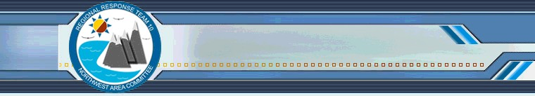
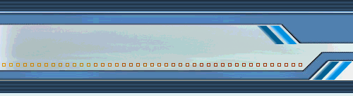
NWACP 7th Annual Summit

7th Annual Northwest Area Contingency Plan Summit
December 7, 2017

Date, Time and NEW Location

December 7, 2017, 8:30 – 4:30 PM

South Auditorium, Jackson Federal Building
915 2nd Ave, Seattle, WA 98174

The south auditorium is on the fourth floor of the Jackson Federal Bldg., use the entrance on 2nd Avenue. Federal employees should bring their CAC cards. All non-Federal attendees will be required to go through a metal detector.

Purpose
The 2017 Northwest Area Contingency Plan 7th Annual Summit will provide an opportunity for broad input on the updates to the 2019 Northwest Area Contingency Plan (NWACP), which will be published in January 2019. This summit will provide the executive committee of the Northwest Area Committee with a prioritized list of plan updates and potential task forces to develop the updates. The executive committee will decide which updates will be analyzed for inclusion in the 2019 NWACP based on the input provided at the annual summit.

For more information on the NW Area Contingency Plan and its role in WA, OR and ID, please see our general brochure or visit our website: www.rrt10nwac.com.

Who Should Attend
Oil and HazMat Spill response organizations, industry, government, non-profit other interested parties or individuals.

Agenda

Time | Description
8:30 – 9:30 | Introduction, Summit Goals & Objectives, Review of outcomes from 2016 Summit and the 2017 Task Forces
9:30 – 10:30 | Issues Discussion
10:30 – 10:45 | Break
10:45 – 12:15 | Small Group Breakout
12:15 – 13:00 | Lunch
13:00 – 14:15 | Breakout Briefings
14:15 – 14:30 | Nominal Process & BREAK
14:30 – 15:00 | Voting Results & Priority Consensus
15:00 – 15:30 | Task Force Volunteers
15:30 – 16:30 | Exercise Discussion

How to Participate

Each organization participating will get 3 minutes and 1 Power Point slide to present the issues that they would like addressed in 2018. These issues may include:

• Plan updates or additions for the 2019 ACP
• Issues that need to be addressed through policy updates that may or may not result in a plan update
• Policies or plans that need to be exercised

If you would like to present issues for review in 2018 then you must follow the instructions on the presentation slide template and email your slide to clark.josie@epa.gov by close of business on November 10, 2017.

If you do not have a presentation then just RSVP to clark.josie@epa.gov or elizabeth.j.petras@uscg.mil. By attending the summit you will be able to help shape the 2019 plan update by identifying work products to be completed by task forces or volunteering for task forces.

Please be sure to complete the advanced reading listed below so that you can fully participate in the discussions.

Advance Reading
Please review the following documents to help prepare for the discussions that we will have during the summit:

• Introduction to the Northwest Area Contingency Plan
• Presentation Slide Template (if presenting proposed updates or issues)
• Draft 2018 NW Area Contingency Plan (please see Preface Section for a listing of content changes)

